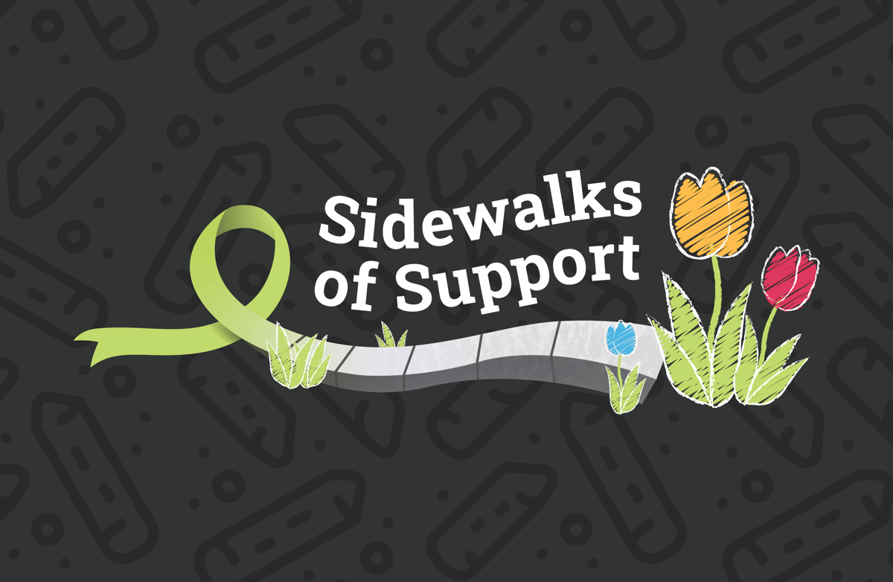

Sidewalks of Support Sample Social Posts

Facebook Option 1
We proudly joined @R&J Strategic Communications’ Sidewalks of Support campaign by turning our sidewalks into spaces of hope and connection. Our team shared uplifting messages that reflect the heart of the work we do every day to support mental health and help people feel seen and supported.
#SidewalksOfSupport #MentalHealthAwarenessMonth #MentalHealthMatters #SupportAndConnection #YouAreNotAlone #SupportStartsHere #WordsMatter #HopeInEveryWord

Facebook Option 2
As part of @R&J Strategic Communications’ Sidewalks of Support campaign, we paused our busy day-to-day and came together to create colorful reminders of care, resilience, and community.

This simple act reconnected us with each other and with the heart of our mission. Check out the photos below. 🌟

#SidewalksOfSupport #MentalHealthAwarenessMonth #MentalHealthMatters #SupportAndConnection #YouAreNotAlone #SupportStartsHere #WordsMatter #HopeInEveryWord

LinkedIn Option 1
We participated in @R&J Strategic Communications’ Sidewalks of Support campaign by creating chalk messages that speak to the heart of our work: connection, hope, and mental wellness. Our team came together to share encouragement and highlight the essential role we play in our community’s mental health.

This moment gave us the opportunity to reflect on @NAMI’s theme — “Stigma grows in silence. Healing begins in community.” — and to visibly support the people we serve every day. Check out the photos below! 🌟

#SidewalksOfSupport #MentalHealthAwarenessMonth #MentalHealthMatters #SupportAndConnection #YouAreNotAlone #SupportStartsHere #WordsMatter #HopeInEveryWord

LinkedIn Option 2
On May 28th, our team stepped away from our routines and into a moment of creativity and connection.

As part of @R&J Strategic Communications’ Sidewalks of Support campaign, we shared uplifting messages that encouraged resilience and reminded our community that mental health matters.

One in five U.S. adults — approximately 59.3 million people — experience a mental illness each year (National Institute of Mental Health). Our chalk messages aren’t just words. They are reminders of the purpose that guides our work every day. Check out the photos below!

#SidewalksOfSupport #MentalHealthAwarenessMonth #MentalHealthMatters #SupportAndConnection #YouAreNotAlone #SupportStartsHere #WordsMatter #HopeInEveryWord

X/Bluesky Option 1
We joined @randjsc’s #SidewalksOfSupport campaign to spread mental health awareness in our community.
Our team used sidewalk chalk to share messages of support, strength, and hope, showing that even small acts can spark meaningful connection. Check it out!
#SidewalksOfSupport #MentalHealthAwarenessMonth #MentalHealthMatters #SupportAndConnection #YouAreNotAlone #SupportStartsHere #WordsMatter #HopeInEveryWord

X/Bluesky Option 2
Our team participated in @randjsc’s Sidewalks of Support campaign by filling the pavement with positive messages to remind our community that they are never alone and that mental health matters. Check out the photos below!

#SidewalksOfSupport #MentalHealthAwarenessMonth #MentalHealthMatters #SupportAndConnection #YouAreNotAlone #SupportStartsHere #WordsMatter #HopeInEveryWord

Instagram Option 1
The [Insert Your Organization Here] team looks good in green! Take a look at our colorful chalk messages spreading positivity, building connections, and raising mental health awareness through @randjsc’s Sidewalks of Support campaign. 💚

#SidewalksOfSupport #MentalHealthAwarenessMonth #MentalHealthMatters #SupportAndConnection #YouAreNotAlone #SupportStartsHere #WordsMatter #HopeInEveryWord

Instagram Option 2
The [Insert Your Organization Here] team is going green for #MentalHealthAwarenessMonth! We spent our day drawing colorful chalk messages to spread positivity and show support for mental health through @randjsc’s Sidewalks of Support campaign. 💚 Check it out!

#SidewalksOfSupport #MentalHealthAwarenessMonth #MentalHealthMatters #SupportAndConnection #YouAreNotAlone #SupportStartsHere #WordsMatter #HopeInEveryWord

Instagram/Facebook Story Option
Chalk full of inspiration 💚 Our team members are proudly wearing green in honor of #MentalHealthAwarenessMonth! Check out our colorful chalk messages spreading positivity, support and hope.

GRAPHIC TEMPLATES:
https://www.canva.com/design/DAGnpPSo5cQ/qScJ64pHUUnac04FOOuqHQ/edit?utm_content=DAGnpPSo5cQ&utm_campaign=designshare&utm_medium=link2&utm_source=sharebutton

